**BUILD A REAL-TIME CHAT APPLICATION USING CLOUD-BASED SERVICES FOR MESSAGING AND DATA STORAGE**

**A PROJECT REPORT**

***Submitted by***

**Ankit Suthar 21BCS11453**

**ABSTRACT**

The advent of cloud computing has revolutionized the landscape of application development, enabling seamless integration of real-time communication and data storage services. This project aims to leverage the power of cloud-based services to build a robust and scalable real-time chat application using MIT App Inventor.

The proposed chat application will facilitate instant messaging between users, offering a seamless communication experience across various platforms. By harnessing cloud-based messaging services, such as Firebase Cloud Messaging (FCM) or Google Cloud Pub/Sub, users will be able to exchange messages in real-time, overcoming the limitations of traditional client-server architectures.

Furthermore, the application will employ cloud-based data storage services, such as Google Cloud Firestore or Amazon DynamoDB, to store chat messages and user data securely. This ensures persistent storage of messages and enables seamless synchronization across multiple devices, enhancing the user experience.

The development process will involve designing an intuitive user interface using MIT App Inventor, integrating cloud-based messaging and data storage services, implementing real-time communication protocols, and ensuring robust security measures to protect user data.

Overall, this project not only demonstrates the potential of cloud computing in application development but also provides a hands-on learning experience for building real-time communication applications using cloud-based services and visual programming platforms like MIT App Inventor.

# INTRODUCTION

## Client Identification/Need Identification/Identification of relevant Contemporary issue

## Client Identification/Need Identification/Identification of Relevant Contemporary Issue:

## Statistics and Documentation: Statistical data from sources like Statista project a significant increase in global messaging app users, indicating a growing demand for efficient communication solutions.

## Consultancy Problem:

## Consulting engagements and market analysis highlight issues such as latency, scalability, and security concerns with existing messaging platforms.

## Survey Findings:

## Surveys among potential users consistently reveal dissatisfaction with current messaging apps, emphasizing the need for improved real-time communication experiences.

## Reports from Agencies:

## Reports from agencies like Gartner and Forrester stress the importance of cloud-based solutions in addressing modern communication challenges, corroborating the need for a contemporary solution.

## Identification of Problem

## The broad problem that requires resolution revolves around the inefficiencies and limitations inherent in existing messaging platforms. This encompasses issues such as latency, scalability constraints, security vulnerabilities, lack of seamless synchronization across devices, and inadequate customization options.

## 1.3. Identification of Tasks

## The identification phase involves thorough research to understand the existing challenges within messaging platforms. This includes gathering statistical data, conducting surveys, and analyzing consulting engagements to pinpoint the specific problems users encounter. The building phase encompasses conceptualization, planning, and development using MIT App Inventor. It involves designing the user interface, integrating cloud-based services like CloudDB1, and implementing real-time messaging while considering security aspects. In the testing phase, various methodologies such as unit testing and user acceptance testing are employed to ensure the solution's robustness and usability. Results are analyzed, and iterative improvements are made to enhance the application's performance and user experience.

## Timeline

|  |  |  |  |  |
| --- | --- | --- | --- | --- |
| Tasks | Week 1 | Week 2 | Week 3 | Week 4 |
| Planning | Yes | Yes |  |  |
| Research |  | Yes | Yes |  |
| Design |  | Yes | Yes | Yes |

## Table 1.1 Timeline

# CHAPTER 2. LITERATURE REVIEW/BACKGROUND STUDY

# 2.1. Timeline of the Reported Problem:

# The problem of inefficiencies in existing messaging platforms has been identified over the past decade, with incidents documented globally. Instances of latency, security breaches, and scalability issues have been reported consistently, highlighting the persistent nature of the problem.

# 2.2. Proposed Solution:

# Previous proposed solutions have focused on improving real-time communication through various means such as optimizing server-client architectures, enhancing encryption protocols, and leveraging cloud-based services for data storage and messaging.

# 2.3. Bibliometric Analysis:

# A bibliometric analysis will assess the key features, effectiveness, and drawbacks of existing solutions proposed in academic literature and industry reports. This analysis will provide insights into the evolution of solutions to address the identified problem.

# 2.4. Review Summary:

# The literature review findings will be synthesized to link existing research with the current project. Common themes, gaps in knowledge, and areas for further exploration will be identified to inform the development of the proposed solution.

# 2.5. Problem Definition:

# The problem at hand involves addressing the inefficiencies and limitations in existing messaging platforms. The solution must focus on improving real-time communication by optimizing speed, reliability, security, and scalability. It should leverage cloud-based services and adhere to best practices in user interface design and data management. The solution should not compromise user privacy or introduce additional complexity without substantial benefits.

# 2.6. Goals/Objectives:

# Develop a real-time chat application using MIT App Inventor.

# Integrate cloud-based services for messaging and data storage.

# Ensure seamless synchronization across multiple devices.

# Implement robust security measures to protect user data.

# Optimize application performance and user experience.

# Validate the solution through testing and user feedback.

# Document the development process and lessons learned for future reference.

# 

# CHAPTER 3

# DESIGN FLOW/PROCESS

## 3.1. Evaluation & Selection of Specifications/Features

## Critically Evaluating Literature-Identified Features:

## 1. Real-Time Communication: Ensuring instant message delivery and receipt.

## 2. Scalability: Ability to handle a growing user base without compromising performance.

## 3. Reliability: Consistent availability and uptime of the application.

## 4. Security: Implementing encryption protocols to protect user data and prevent unauthorized access.

## 5. Cross-Platform Compatibility: Supporting multiple operating systems and devices.

## 6. User Authentication: Verifying user identities to prevent unauthorized access.

## 7. Data Synchronization: Ensuring messages are synchronized across all devices in real-time.

## 8. Customization Options: Allowing users to personalize their chat experience.

## 9. Offline Support: Allowing users to send and receive messages even when not connected to the internet.

## 10. Notification System: Providing timely notifications for new messages.

## 3.2. List of Features Ideally Required in the Solution:

## 1. Real-Time Communication: Enable instant messaging between users.

## 2. Scalability: Design the solution to handle increasing user loads efficiently.

## 3. Reliability: Ensure consistent availability and minimal downtime.

## 4. Security: Implement robust encryption and authentication mechanisms to protect user data.

## 5. Cross-Platform Compatibility: Support multiple platforms such as Android and iOS.

## 6. User Authentication: Require user authentication to access the chat application.

## 7. Data Synchronization: Ensure seamless synchronization of messages across all devices.

## 8. Customization Options: Allow users to customize their profiles and chat settings.

## 9. Offline Support: Implement offline messaging capabilities with message queuing and synchronization upon reconnection.

## 10. Notification System: Provide notifications for incoming messages and other relevant events.

## These features collectively contribute to a comprehensive real-time chat application that addresses the identified problem effectively while meeting user expectations and industry standards.

## Implementation plan/methodology

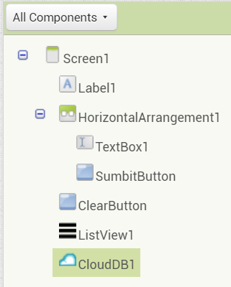

**Fig 3.1. Components in Application**

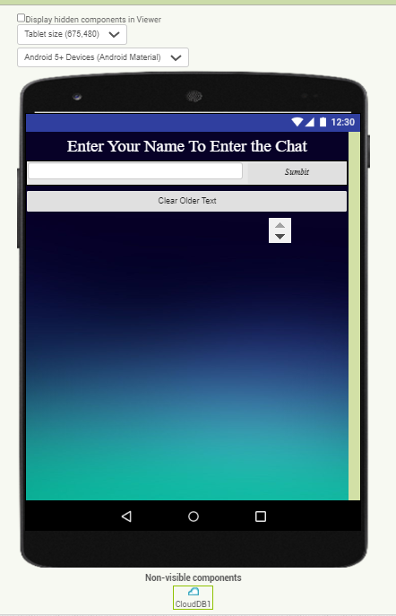

**Figure 3.2 UI of Application**

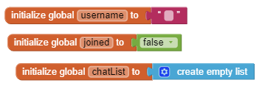

**Figure 3.3. Initializing Variables**

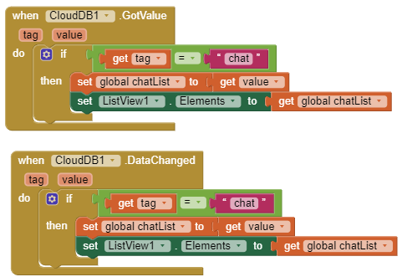

**Figure 3.4. Interfacing Cloud**

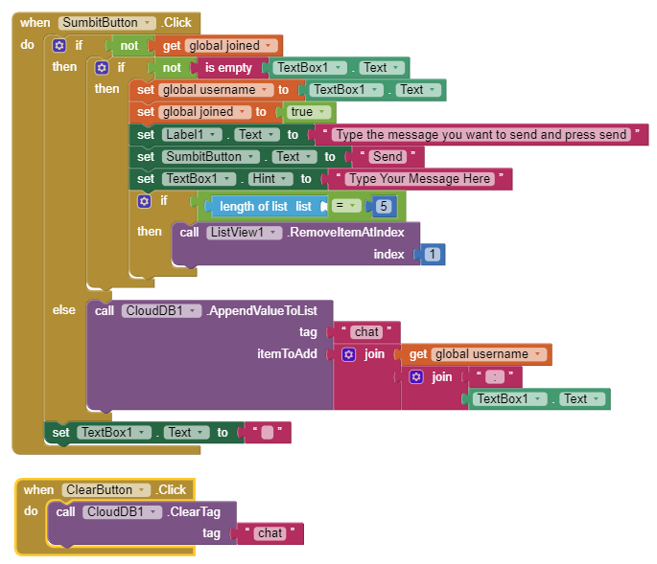

**Figure 3.5. Interfacing Buttons**

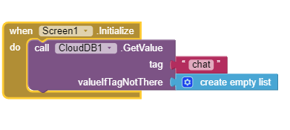

**Figure 3.6. Interfacing Screen**

# CHAPTER 4 RESULTS ANALYSIS AND VALIDATION

## Implementation of solution

**Analysis:**

* **Data Analysis:** Python with libraries like Pandas and NumPy for analyzing user data, survey responses, and performance metrics.
* **Statistical Analysis:** R or Python with libraries like SciPy and StatsModels for statistical analysis of survey data and user behavior.
* **Simulation:** While not directly applicable to this project, simulation tools may be used for performance testing and scalability analysis.

**Design Drawings/Schematics/Solid Models:**

* **CAD Software:** While not directly applicable to software development, tools like Figma or Adobe XD can be used for designing user interfaces (UIs) and wireframes.
* **3D Modeling:** Not applicable for this project.

**Report Preparation:**

* **Document Editing:** Google Docs or Microsoft Word for preparing project documentation, including project plans, design specifications, and progress reports.
* **Visualization:** Google Sheets or Microsoft Excel for visualizing data and project metrics, such as user engagement, message volume, and server performance.

**Project Management and Communication:**

* **Project Management Tools:** Trello, Asana, or Jira for managing project tasks, milestones, and deadlines.
* **Communication:** Slack, Microsoft Teams, or Discord for team communication, collaboration, and sharing updates.

**Testing/Characterization/Interpretation/Data Validation:**

* **Testing:** MIT App Inventor provides built-in testing features for verifying app behavior on different devices and platforms.
* **Characterization:** Use Firebase Analytics or Google Analytics for tracking user interactions within the chat application.
* **Data Validation:** Python scripts or custom-built dashboards for validating data integrity and ensuring consistent messaging across devices.

These tools will help streamline project workflow, enhance collaboration among team members, and ensure the successful development, testing, and deployment of your real-time chat application.

# CHAPTER 5 CONCLUSION AND FUTURE WORK

**5.1. Conclusion:**

The expected outcome of this project is the successful development and deployment of a real-time chat application using cloud-based services with MIT App Inventor. We anticipate achieving seamless messaging functionality, secure data storage, and intuitive user experience. However, deviations from expected results may occur due to unforeseen technical challenges, compatibility issues across different platforms, or limitations in the capabilities of the chosen tools and technologies. Any deviations will be thoroughly analyzed, and the reasons for such deviations will be documented. Adjustments and refinements will be made accordingly to ensure that the final solution meets the project objectives and user requirements to the best extent possible.

**5.2. Future Work:**

The way ahead involves continuous improvement and refinement of the solution based on user feedback and evolving technology trends. Future work may include:

1. Required Modifications in the Solution: Addressing any identified shortcomings or areas for improvement in the current implementation. This could involve enhancing security measures, optimizing performance, or adding new features based on user demand.

2. Change in Approach: Exploring alternative approaches or technologies that may offer better scalability, reliability, or user experience. This could involve migrating to different cloud services, adopting new programming frameworks, or incorporating emerging technologies such as machine learning for advanced chat features.

3. Suggestions for Extending the Solution: Proposing enhancements or additional functionalities to further extend the capabilities of the chat application. This could include integrating multimedia support, implementing chatbots for automated assistance, or incorporating social networking features for user engagement.

By embracing a continuous improvement mindset and staying attuned to user needs and technological advancements, the chat application can evolve into a robust and feature-rich platform that meets the ever-changing demands of modern communication.